CIRCUIT DIAGRAM:

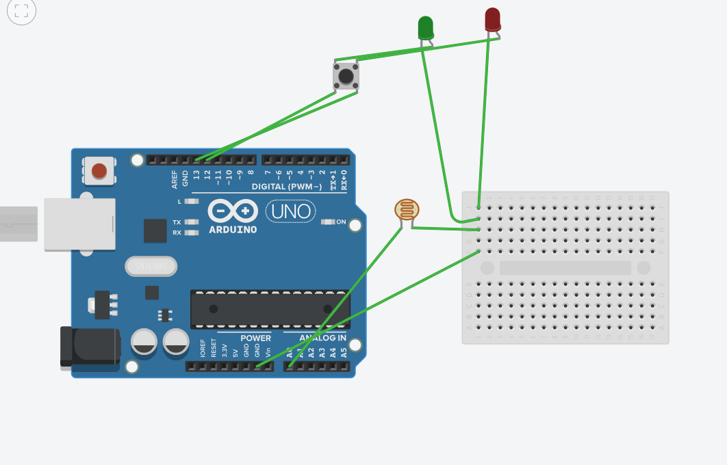

**Theory:**

Concept used: LDR(Light Dependent Resistor) and Arduino knowledge

LEARNING AND OBSERVATION: The LDR works upon the intensity of the light it receives.

**PROBLEMS AND TROUBLESHOOTING**

This was hard at first but I did it somehow.

**PRECAUTIONS**

Separate wires for each and should be connected using breadboard instead of using them on Arduino uno board. Make the wires coloured to distinguish between them.

Write program with precautions.

**LEARNING OUTCOMES:**

Learned how to engineers take the help of the Arduino to and for various different applications.